**Create a media folder and upload jpeg image**

**Skeleton of how it will look like**

my_project/

├── media/

│ └── image.jpeg

├── my_app/

├── my_project/

├── manage.py

└── ...

**Settings.py**

import os

BASE_DIR = os.path.dirname(os.path.dirname(os.path.abspath(__file__)))

MEDIA_URL = '/media/'

MEDIA_ROOT = os.path.join(BASE_DIR, 'media')

**views.py**

from django.shortcuts import render

from django.conf import settings

from django.http import HttpResponse, Http404

import os

def image_response_view(request):

image_path = os.path.join(settings.MEDIA_ROOT, 'image.jpeg')

if os.path.exists(image_path):

with open(image_path, 'rb') as f:

return HttpResponse(f.read(), content_type='image/jpeg')

else:

raise Http404("Image not found")

**Start app**

**urls.py**

from django.conf import settings

from django.conf.urls.static import static

from django.urls import path

from . import views

urlpatterns = [

path('image/image/', views.image_response_view, name='image_response_view'),

] + static(settings.MEDIA_URL, document_root=settings.MEDIA_ROOT)

**Start project**

**Urls.py**

from django.contrib import admin

from django.urls import path,include

urlpatterns = [

path('admin/', admin.site.urls),

path('image/',include('imageurl_app.urls'))

]

**Output**

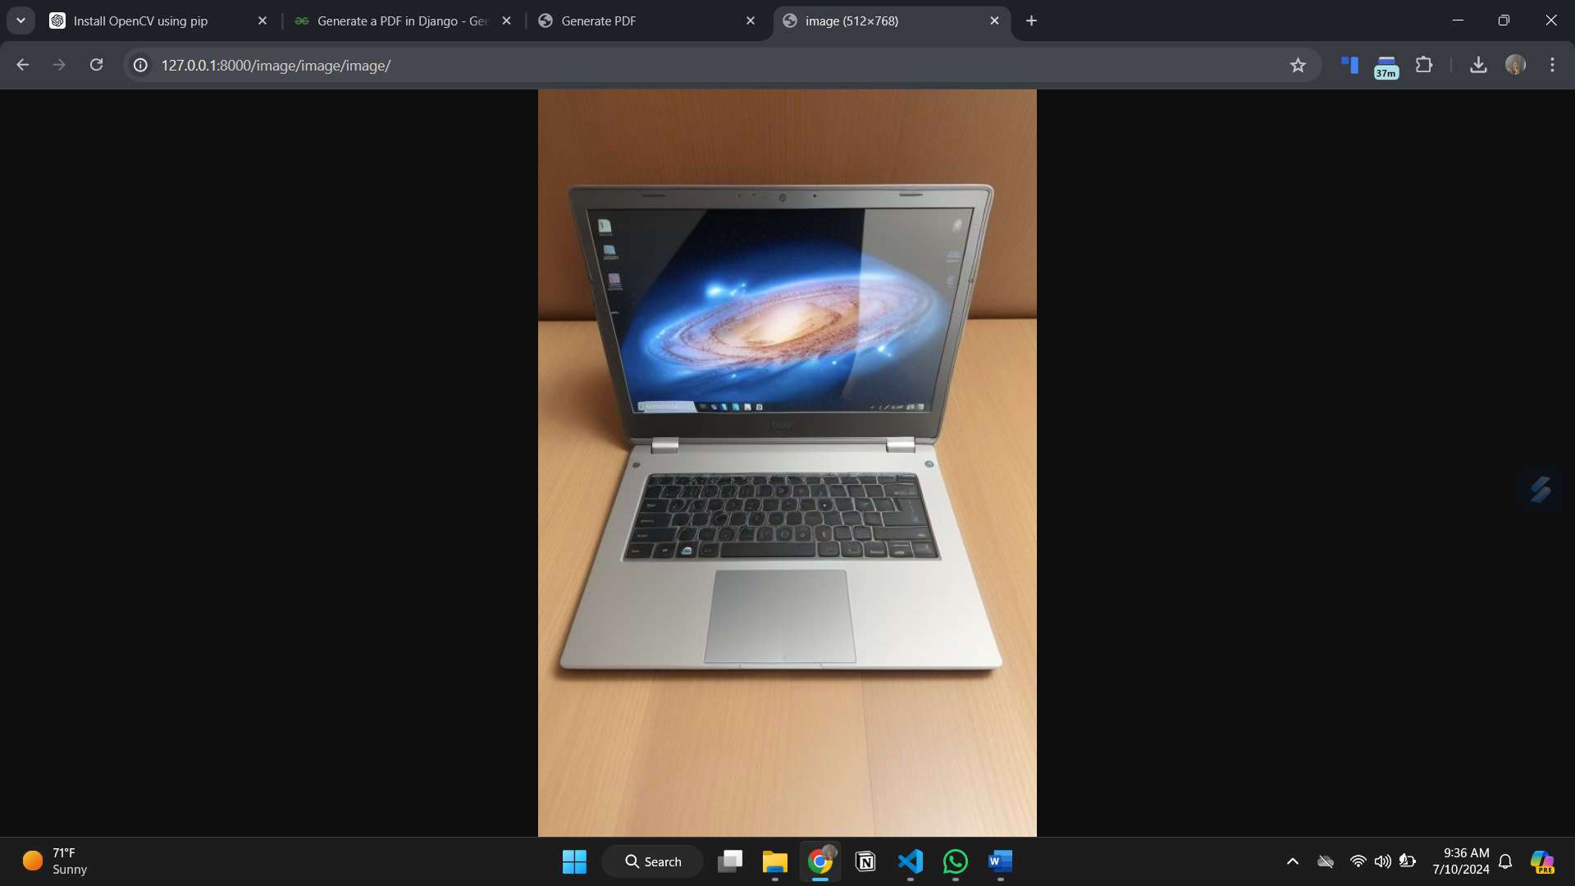

**For PDF File**